**Software design document**

Name:

Salom Armand

Florea Calin

Orzescu Tiberius

**TABLE OF CONTENTS**

1. INTRODUCTION 1.1 Purpose 1.2 Scope 1.3 Overview 1.4 Definitions and Acronyms

2. SYSTEM OVERVIEW

3. SYSTEM ARCHITECTURE 3.1 Architectural Design 3.2 Decomposition Description 3.3 Design Rationale

4. DATA DESIGN 4.1 Data Description 4.2 Data Dictionary

5. COMPONENT DESIGN

6. HUMAN INTERFACE DESIGN 6.1 Overview of User Interface

6.2 Screen Images

6.3 Screen Objects and Actions

**1. INTRODUCTION**

**1.1** **Purpose**

Identify the purpose of this SDD and its intended audience. (e.g. “This software design document describes the architecture and system design of XX. ….”).

The SDD paper is intended for programmers, system administrators and database administrators to describe the architecture and design of the project.

**1.2 Scope**

Provide a description and scope of the software and explain the goals, objectives and benefits of your project. This will provide the basis for the brief description of your product.

The company “Fly with me” is one of Europe's fastest growing airlines and the leading low cost carrier in Central and Eastern Europe was named top ten safest low cost carriers of 2019 in the world by the world's only one-stop airline safety.

Web application is created to simplify everything for our passengers(to show them all possible route and also to buy tickets online)

## 

## **1.3** **Overview**

The document is spread in 8 different chapters , each with numerous subchapters. Each chapter formulates concepts regarding different parts of the project.

## **1.4** **Definitions and Acronyms**

|  |  |
| --- | --- |
| User | Person who interacts with the application |
| Member | User that has agreed to register and purchased the membership |
| Administrator | Staff member with special permissions and privileges who manages and controls the system |
| Resources | Object or places belonging to the art club that can be rented to members for events. |
| Fees | Costs required for creating an event (200 lei/day/resource if the user bought a membership or 400 lei/day/resource if the user did not buy a membership) or the monthly payment |
| Event | Meeting organized by a member/user/admin using the application. The meeting requires the use of different resources (provided by the art club) and funds(payment fees). |

**2. System Overview**

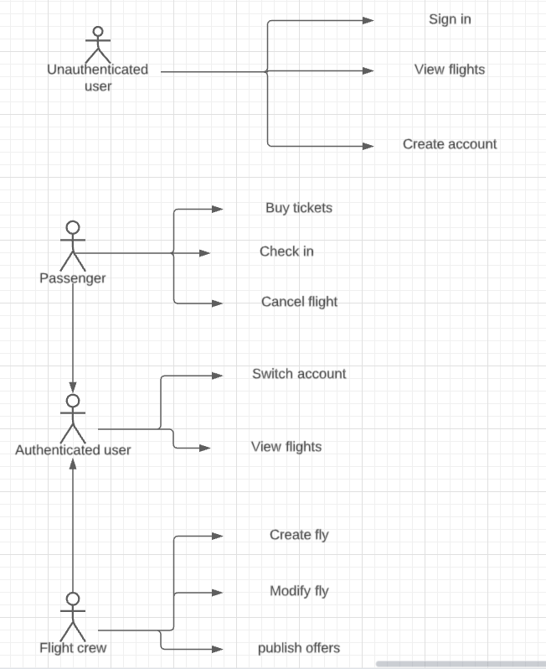

# **3. SYSTEM ARCHITECTURE**

## **3.1 Architectural Design**

**3.2 Decomposition Description**

## **3.3. Design Rationale**

The web architecture has been chosen because it allows the use of the application in a decentralized way and the maintenance of the application is simplified

**4.Data Design**

**4.1.Data Description**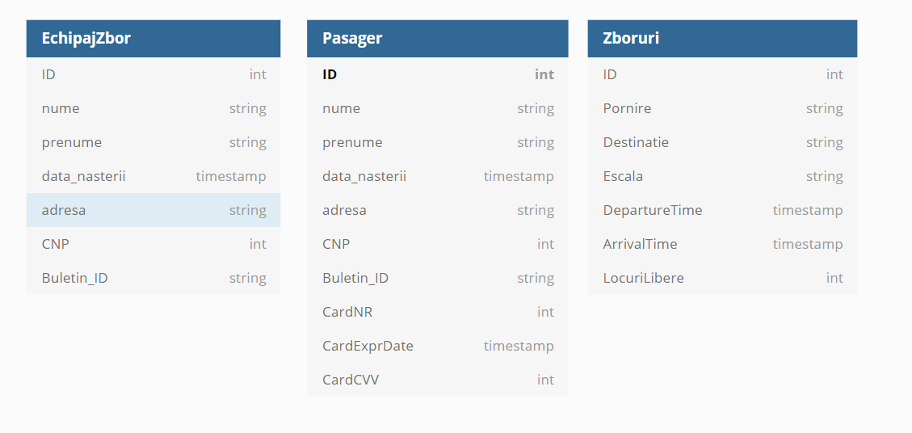

**4.2 Data Dictionary**

Alphabetically list the system entities or major data along with their types and descriptions. If you provided a functional description in Section 3.2, list all the functions and function parameters. If you provided an OO description, list the objects and its attributes, methods and method parameters.

**5. Component Design**

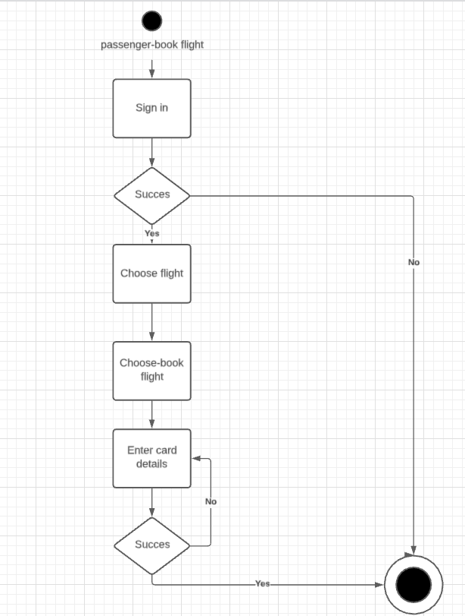

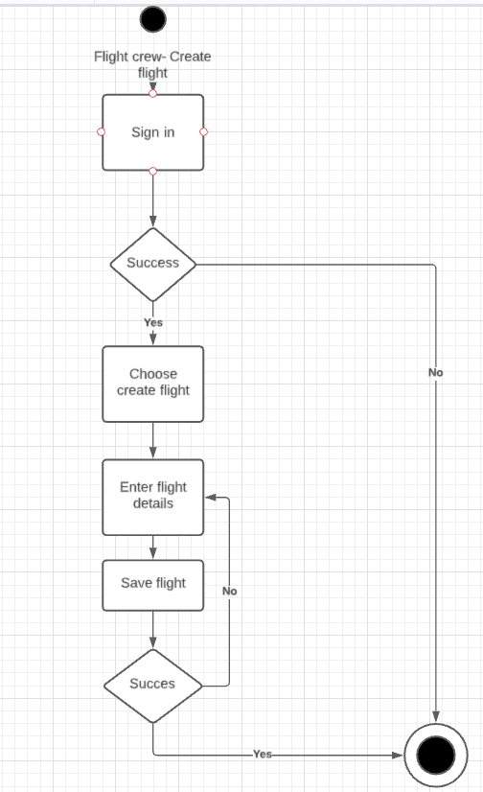

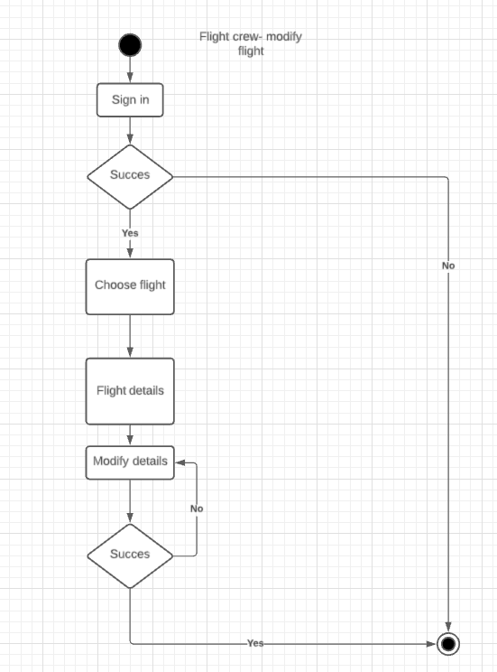

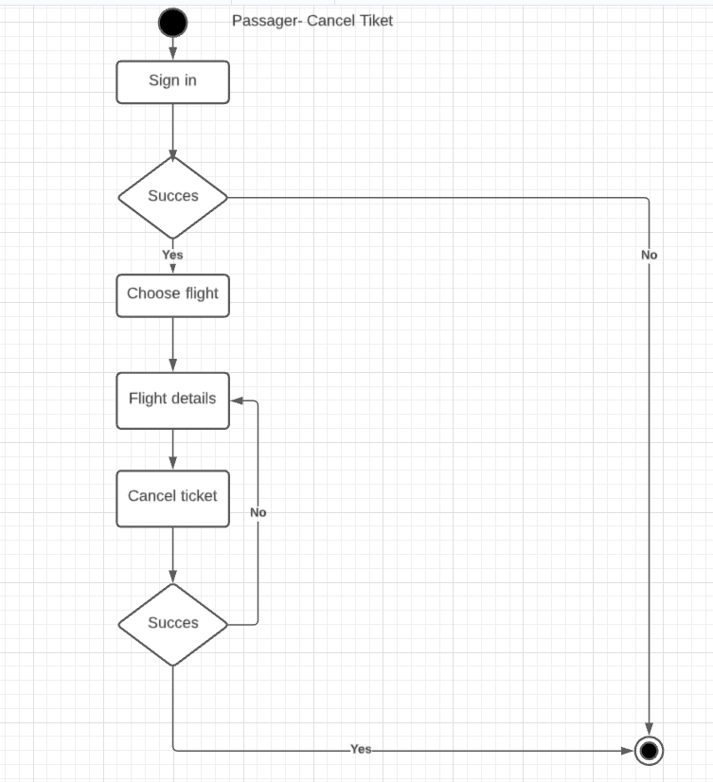

**6.HUMAN INTERFACE DESIGN**

## **6.1 Overview of User Interface**

The user interface of this program consists in a list of diferent required options to fill like “Nume”, “Prenume”, “Email” etc.

## **6.2 Screen Images**

## 

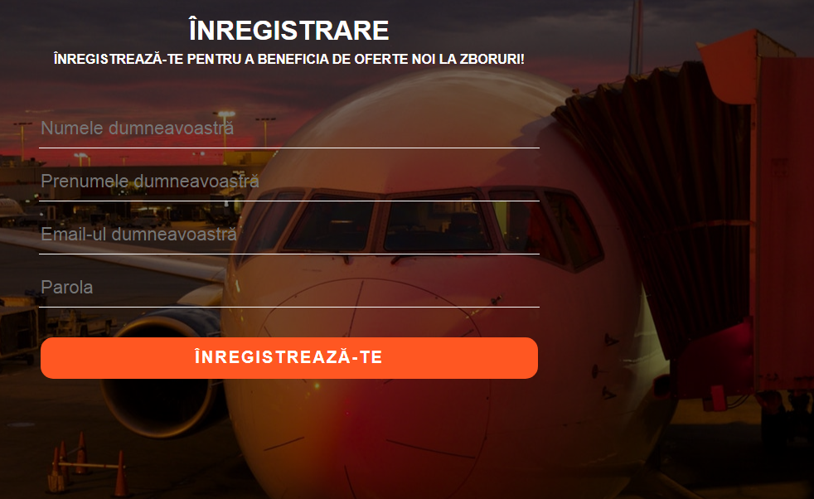

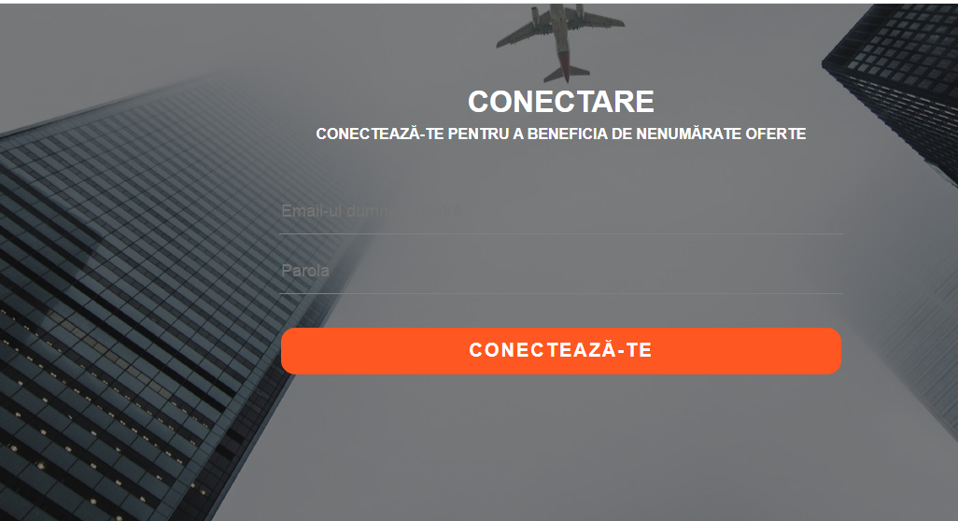

**6.3 Screen Objects and Actions**

A discussion of screen objects and actions associated with those objects.